European Day of Languages
On Monday 26th September we celebrated European Day of Languages. Our focus as a school this year was on the importance of learning new languages to help us become global citizens. We learnt how learning new languages help us make new friends, understand different cultures and give us an opportunity to travel and study abroad. The whole school took part from Nursery to Year 6, and it was fabulous to see so many of the children and staff in their traditional clothes.
Nursery enjoyed listening to the Ukrainian national anthem whilst colouring in flags, Pixie Class was very excited to be learning Portuguese, Year 1 learned to sing French nursery rhymes and Year 2 sang numbers 1-10 in Greek!
In KS2 the children took part in learning words and phrases from various European languages. Year 6 took part in some very impressive role-play in Slovak. Videos on our Instagram page coming soon!
We are so proud of all the children at Pippins, who embraced the day of learning different languages and cultural heritage. We hope they are inspired to take on a lifelong journey of learning languages.
Mrs Rehinsi
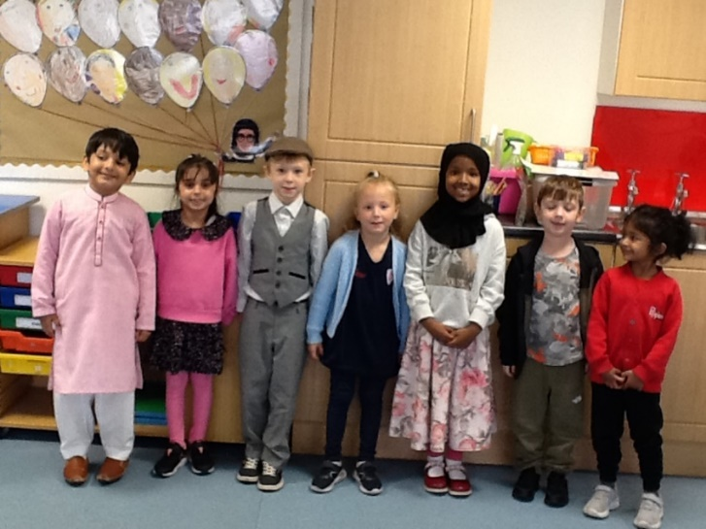
To learn a language is to have one more window from which to look at the world – Chinese Proverb

