Click on the videos below to view our ‘Pippins Experts’ speaking key phrases in Punjabi!

language of the month
Hello, my name is.. (year 3)
Hello, Goodbye (year 1)
Yes (year 5)
how are you?(year 6)

Numbers (year 2)
Numbers (year 4)

Who speaks Punjabi?

The Punjab is a region straddling the border between India and Pakistan.
An estimated 26 million Punjabi speakers live in northern India. In neighbouring Pakistan there are roughly 40 million Punjabi speakers. Indian Punjabi is distinct in its dialect and writing script when compared to Pakistani Punjabi. Indian Punjabi is mostly spoken by Sikhs.
Punjabi is spoken by about 70 million people worldwide.

Year 1 enjoying some bhangra dancing – a highly energetic traditional dance from Punjab! Why not have a go at home!

We also talked about Vaisakhi – a harvest festival from Punjab and a celebration full of colour in the Sikh community.
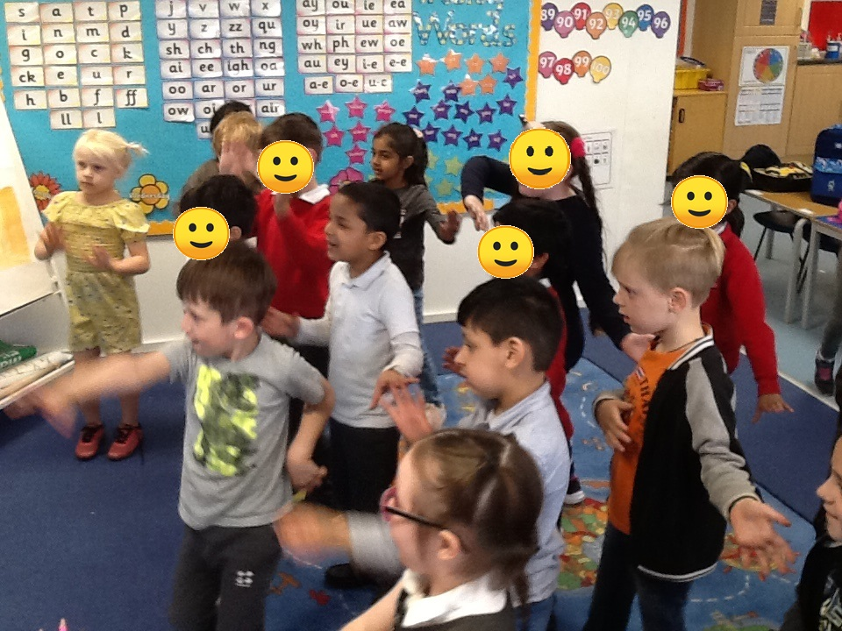
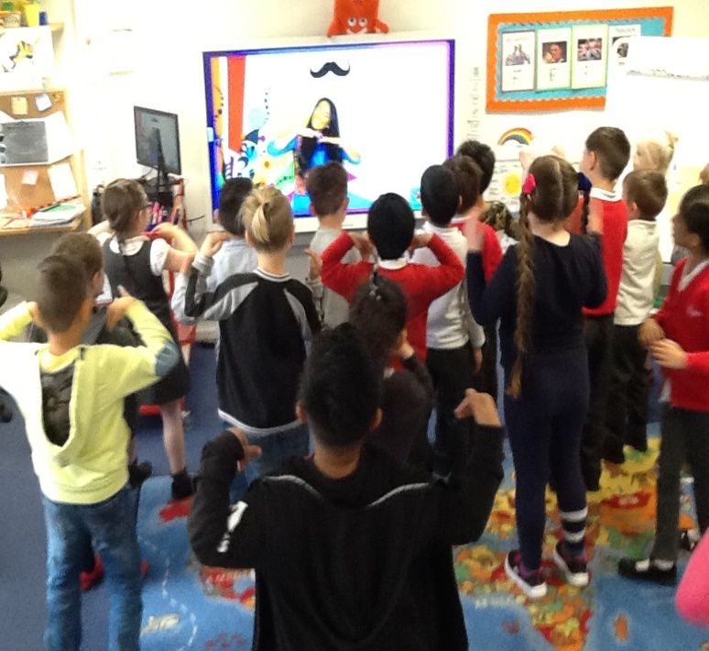
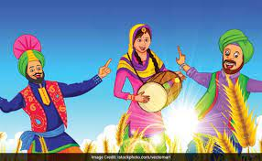

Our Punjabi ‘experts’ across the school!
